R Assignment 1

Jacey Davies

9/3/2020

Generating the data using UFID:

set.seed(21825314)  
mydata=rnorm(100,30,2)

Finding the sample mean:

mean(mydata)

## [1] 29.77138

Finding the sample median:

as.numeric(quantile(mydata, probs=0.5))

## [1] 30.03733

Finding the 10% trimmed mean:

mean(mydata, trim=0.1)

## [1] 29.82096

Finding the 35th percentile:

as.numeric(quantile(mydata, probs=0.35))

## [1] 29.25401

Plotting the data as a histogram:

hist(mydata, xlim=c(24,34), xlab="Value", ylab="Frequency", main="Histogram for Generated Data")

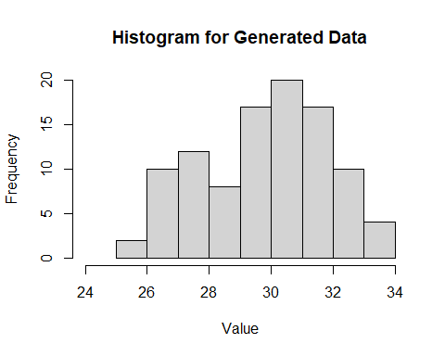

The histogram is skewed left with the peak appearing at 30-31. The data follows a skewed bell curve for the most part, with the exception of the 28-29 category, which is much lower than its neighboring categories. This probably would not be fixed by narrowing the bin widths but may be helped by widening them. However, widening the bin widths may cause important details to be hidden; this dip may be considered as an important detail. Thus, the automatically generated bin widths were used for this histogram.